Project Design Phase-I Solution Architecture

|  |  |
| --- | --- |
| Date | 05 November 2022 |
| Team ID | PNT2022TMID09952 |
| Project Name | IoT Based Safety Gadget for Child  Safety Monitoring and Notification |
| Maximum Marks | 4 Marks |

Solution Architecture Diagram:

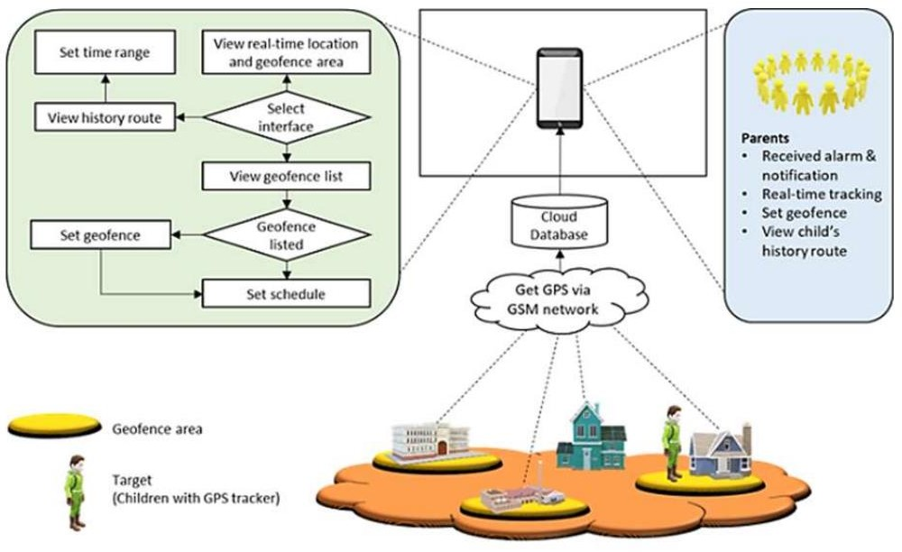

Architecture and data flow of the Child Safety Monitoring and Notification